IFSA Delegation Report

UNFCCC COP22
Nov 7th-25th
Marrakech, Morocco

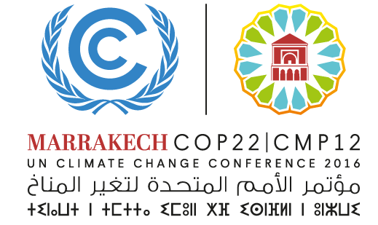

By Charlotte Ross-Harris
7th December 2016
charlotte.ross.harris.ifsa@gmail.com
Table of Contents
The United Nations Framework Convention on Climate Change 3
UNFCCC 3
Parties 3
The COP 3
Paris Agreement 4
IFSA's role in UNFCCC 6
IFSA's Participation 7
Delegation 7
Side Events 8
Conclusion 9
COP22 Blog 9
FROM THE SOUKS TO THE BLUE ZONE 10
DAY THREE: QUALITY GLOBAL FOREST SURVEYS USING SATELLITES AND TRUMP TRUMP TRUMP 11
PROMOTING SOCIAL FORESTRY IN INDONESIA 13
DAY FOUR: YOUTH AND FUTURE GENERATIONS IN CLIMATE 14
GROUNDED SOIL 15
FUTURE VISIONS 16

The United Nations Framework Convention on Climate Change

UNFCCC
The UNFCCC is an international treaty that was negotiated at the Earth Summit 1992 in Rio de Janeiro. The aim of the convention is to limit greenhouse gas emissions in order to tackle the challenge of climate change. In 2016, 197 parties have ratified the convention. Therefore, UNFCCC is the most important political platform to address and debate climate change.

Parties
Generally, the Parties can be divided into three major groups: Annex I Parties, Annex II
Parties, and Non-Annex I Parties.
Annex I Parties include the industrialized countries that were members of the OECD (Organization for Economic Cooperation and Development) in 1992, and countries with economies in transition (EIT Parties). The latter are Russia, the Baltic States, and several Eastern European states.
Annex II Parties consist of the OECD members of Annex I excluding the EIT Parties. Annex II Parties are required to provide technology transfer and financial and technical support to EIT Parties and developing countries in order for them to adapt to climate change and undertake mitigation efforts.
Non-Annex I Parties are mostly developing countries and receive financial aid, technical advice, and capacity building from the developed countries according to the Convention.
The 195 member parties organize themselves in various interest groups.

The COP
The Conference of Parties (COP) is the supreme decision making body of the UNFCCC. It is held annually and hosted by a different party each year. The major purpose of the conference is to review the implementation of the convention as well as to discuss and agree on arrangements and measures to successfully implement the convention.
Typically, a UNFCCC COP lasts two weeks. In the first week, scientific results are being presented and discussed by two main groups: the Subsidiary Body for Scientific and Technological Advice (SBSTA) and the Subsidiary Body for Implementation (SBI). These two groups meet throughout the year to investigate scientific data and technical solutions as well as to explore the challenges of implementing the policies on the ground.
Besides the meetings of SBSTA and SBI, the Ad Hoc Working Group on the Durban Platform for Enhanced Action (ADP) hold meetings to finalize a draft agreement of the conference which also assists delegations in their preparations for the negotiations.
In the second week, the High-level Segments are being introduced by an official opening ceremony where the current COP president, the UNFCCC secretary, and other official representatives welcome the ministers of the participating countries. Throughout the second week, presidents and environmental ministers of the countries hold speeches about their countries’ concerns. They voice their countries’ official position and announce their commitments for climate change mitigation and adaptation.
The last days at a COP are dominated by intense, open ended, and very exhausting discussions until a definite document has been concluded.
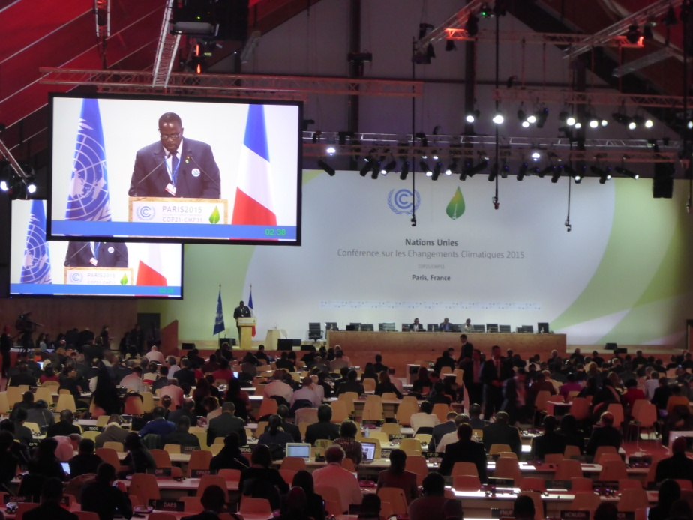
For the past two decades, COP's most prominent task has been to agree on a Post-Kyoto- Agreement, which will supersede the well-known Kyoto-Protocol in 2020. The COP failed to do so at COP15 in Copenhagen 2009, thus the Kyoto-Protocol was extended where the final date for a Post-Kyoto Agreement was scheduled for 2015. Hence expectations for COP21 were high as by many it was seen as last chance to successfully come to a universal legally binding agreement to effectively limit climate change.

Paris Agreement
Prior to COP21 all parties were asked to submit their individual "Intended Nationally Determined Contribution" (INDC). These commitments partly formed the base of the Paris negotiations as they attested the parties' self-set contributions to tackle climate change. 187 parties submitted INDCs preceding COP21, the suggested commitments were estimated to limit climate change to no more than 2.7°C. Thus signs to reach the 2°C-goal were not very promising when the negotiations started on November 30th.
The final outcome of the Paris Agreement and its key decisions may be summarized as follows:
In order to enhance the implementation of the convention the first goal of the agreement is to limit "[...] the increase in the global average temperature to well below 2 °C above pre-industrial levels and to pursue efforts to limit the temperature increase to 1.5 °C above pre-industrial levels [...]". This goal was mainly brought forward by countries of the Southern Hemisphere such as the AOSIS who are strongly affected by climate change already. Also the EU-led High Ambition Coalition played an important role in promoting the ambitious 1.5°C-goal.
The Paris Agreement also envisages to increase "[...] the ability to adapt to the adverse impacts of climate change and foster climate resilience and low greenhouse gas emissions development, in a manner that does not threaten food production".
Furthermore, the Agreement shall foster to "Making finance flows consistent with a pathway towards low greenhouse gas emissions and climate-resilient development". To serve this goal industrialized countries agreed to provide 100 billion US Dollars yearly from 2020 to 2025 to support energy transition, improvement of climate resilience and to compensate damages caused by climate change in developing countries. The money will be partly from private capital investments and partly from governmental funds. Strong emerging countries like China are encouraged to contribute to the financial support of developing countries as well.
Another declared goal of the Agreement is to "reach global peaking of greenhouse gas emissions as soon as possible [...] so as to achieve a balance between anthropogenic emissions [...] and removals by sinks [such as forests and oceans] of greenhouse gases in the second half of the century". The progress being made in the implementation of the Agreement will be reviewed and if necessary revised with the aid of a global stock take. This evaluation will be every five years, starting in 2023.
Post COP21, many nations were quick to sign and approve the Agreement meaning that on October 5 2016, the threshold for entry into force of the Paris Agreement was achieved. This unexpectedly early ratification was heavily aided by the combined forces of the US and China agreeing show some leadership on the issue. It meant that at least 55 parties together responsible for at least 55% of the world’s greenhouse gas emissions had signed and ratified by this date. Therefore, 30 days later, just before the COP22 began, the Agreement entered into force on November 4 2016. The first session of the Conference of the Parties serving as the Meeting of the Parties to the Paris Agreement (CMA 1) took place in Marrakech, Morocco from 15-18 November 2016. Throughout the 2 weeks in Morocco more Parties ratified and currently as of December 2016, 118 Parties have ratified out of 197 Parties that signed the Convention. This currently accounts for 80% of the world’s greenhouse gases.
Therefore, the proceedings at COP22 took place in positive atmosphere - after many years of negotiation finally a new phase focused on implementation and action was underway. It is, however, clear that the transition phase is a challenging one, with many issues to work through. Chief among them is the nature of differentiation between developed and developing countries. The resolution of such issues was not expected to occur in Marrakech, rather the aim was to better understand the many issues involved in laying down the architecture for the Paris Agreement and adopting a work plan to get final decisions by 2018. The rulebook for this convention needs to be formed and at this stage, deadlines for its completion are quite open ended. Also some voices call for a stronger binding agreement with tools and measures to punish parties that do not achieve their intentions, however currently no such punishment exists.
Find the Paris Agreement here: https://unfccc.int/resource/docs/2015/cop21/eng/l09r01.pdf.

IFSA's role in UNFCCC
IFSA has been involved in the international processes of the United Nations for many years, and is a UNFCCC admitted NGO. Each year, the IFSA International Processes Commission (IPC) organizes student delegations to attend conferences and meetings hosted by UNFCCC. IFSA as a non-political, non-religious, and nonprofit organization that participates in the UNFCCC processes as an observer from the civil society. The main objectives of IFSA's participation are to give members the opportunity to attend high profile events such as COP, to raise the voice of youth in accordance with the IFSA-community, but also to critically observe the political processes of climate change negotiations in order to be able to report about the events and personal experiences to fellow IFSA-members as well as schools, communities, etc.
The UNFCCC's major event is the annually held COP but additionally the UNFCCC hosts the Bonn Climate Change Conference, in which IFSA also has the opportunity to become involved.

IFSA's Participation

Delegation
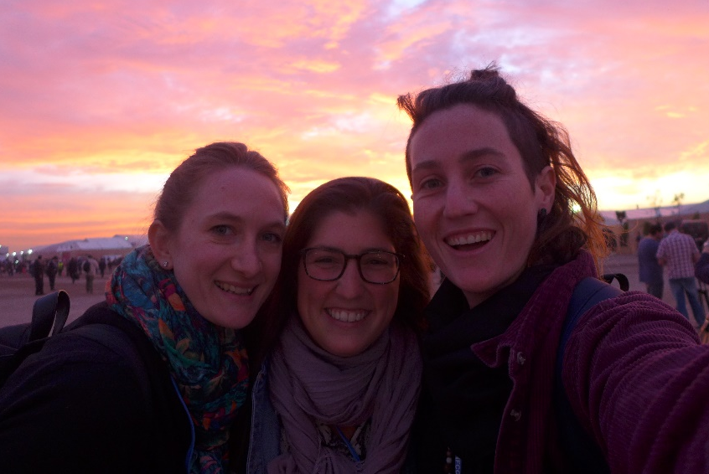
This year’s IFSA delegation consisted of eight students coming from six nations (Australia, Ghana, Canada, Indonesia, Mexico and the US/Eritrea). Four delegates attended each of the two weeks. The delegation was very diverse in terms of heritage and experience, which was very beneficial as it led to the inclusion of many different perspectives in discussions. As well the participants were able to spread themselves over a diverse range of seminars and participate in different languages. The diverse group was chosen deliberately in an attempt to represent those from all corners of the IFSA world.
In addition to this official delegation we were lucky to be joined by some extra IFSA members through other forms of accreditation or their presence at the Global Landscapes Forum in the second week. The Global Landscape Forum acts as a platform for experts, organizations and viewers to exchange knowledge and ideas. The key issues this year were the stopping of deforestation, the sustainable management of landscapes and new methods to achieve these aims. Furthermore, different ideas were shared about how to solve landscape issues, such as the expanding of the dry zones in Africa or the massive deforestation in Latin America.
IFSAs involvement spread from being a representative of the youth, to the participation in the youth in landscapes initiative where some sessions were led by IFSA members. In this session the different groups of youth delegates worked out problems resulting out of migration.
IFSA represented a key amount of the youth delegates with 13 participants.
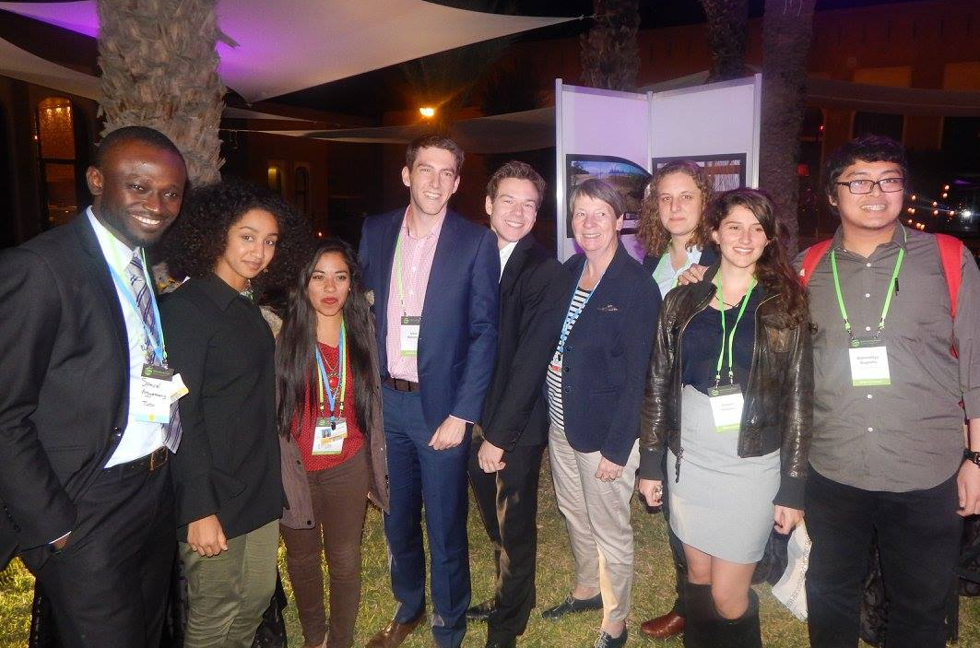

Side Events
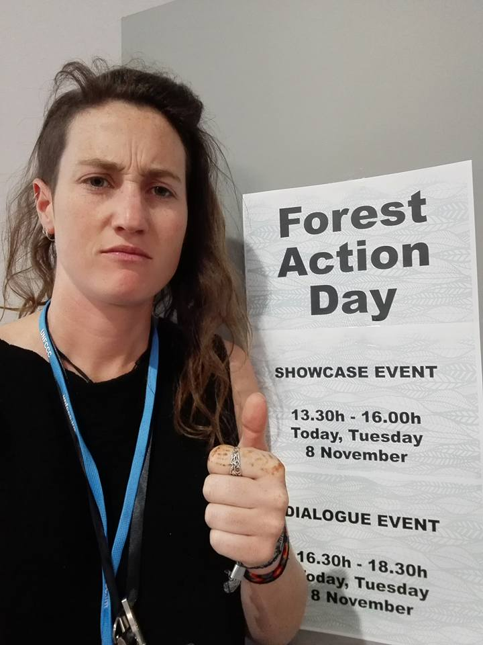
COP hosts hundreds of side events organized by different nations, organizations and companies on specific topics. Some days are themed and many panel discussions and presentations of science will occur around one topic. Naturally the Forest Action Day was interesting to us. Topics such as national emission strategies, challenges for minorities or financing opportunities are just some examples of the many discussions happening in the side event area. The range of topics is so wide and diverse that it is impossible to name them all. As members of an organization with observer status, the access to actual negotiations and speeches is very limited. For this reason, the attendance at side events and open discussions takes up most of the IFSA delegate's time.
Alongside the more formal seminars are many informal information booths held by various organizations or nations that display many climate change related ideas. These can range from displays of the newest innovations in electric cars, or technology to remove waste from our oceans; and representatives from indigenous groups or nuclear power companies. There is so much to learn and opportunities for different groups to advocate for themselves.

Conclusion
COP certainly is one of biggest and most important events one can attend through IFSA. The numerous side events, speeches, demonstrations, press conferences and the grand size of the event make it very desirable for students to attend. Not to mention the sheer importance of the topic at hand – global climate change mitigation. Being at COP is an indescribable opportunity to learn about climate change, equality, justice, policy making processes and many more topics.
COP22 was a very special COP to attend as it engulfed everyone with a strong sense of action and progress, a hugely positive atmosphere and the sensation that the world really does want to change something.
The experience of attending with a diverse IFSA delegation was extremely valuable for everyone involved. It led to the sharing of different perspectives on the same thing, from other sides of the world. As well as informative discussions and new friendships.
Because of the high amount of admitted NGO's, IFSA's role at COP is literally not more than that of an observer. We are extremely fortunate to be there, but do not impact on what happens. For future COP's it could be desirable to get more committed to active networks like the Climate Action Network (CAN) or YOUNGO. This year our relationship with YOUNGO developed and provided a great insight into youth action at COP. The delegation could benefit from connections like that as they provide additional inside information about the negotiation processes and are very helpful to keep up with all kind of news around COP and UNFCCC.

COP22 Blog
At COP22 the success of the previous year’s blog was recreated with the newly launched IFSAblog. This is an excellent medium for sharing the delegation’s thoughts, impressions and experiences through writing blogs or uploading photos and videos of their time at COP. The content was focused around a survey that collated the main topics of interest to the IFSA community. The section below provides an exemplary selection of the blogs.
The blog can be accessed here: https://blogifsa.wordpress.com/
Disclaimer: The views and opinions expressed in this blog are those of the author and do not necessarily represent those of the International Forestry Students’ Association.

FROM THE SOUKS TO THE BLUE ZONE
  - November 7, 2016
By Jen Dawes
They say first impressions always count but yesterday I really hoped they didn’t. After arriving early in the day and settling into my Riad, I ventured out onto the streets of Marrakech. To say it was “busy” is a complete understatement…I encountered a myriad of alleys which were completely overwhelming, stall upon stall in the traditional souks, countless motorbikes and scooters zooming past, and an endless dialogue of locals searching for the next dirham. Needless to say, yesterday was all a bit much… until I met with my fellow week 1 delegates, Charlotte and Vicky. Marrakech suddenly became the wonderful location my friends had told me about, and I finally felt ready for COP22.
Day 1 was wet…very wet! Our morning walk to the shuttle bus in the Medina square left us feeling a little soggy (my shoes, in particular!), yet optimistic at what the day would bring (my shoes were less optimistic as they spent the day in the cloakroom trying to dry!). Upon a bus filled with very important “suits and ties”, I knew I was stepping into a world that had previously felt out of reach, yet today it was right in front of me. Everyone possessed such a charisma for climate change and the Paris Agreement that doesn’t seem to be present back home in Australia. This reinvigorated my sense of passion for working towards the targets and wanting to learn more from those involved.
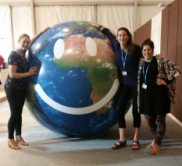
As I went through security it felt like I had returned to the airport, but this time there was no plane…instead, a vast array of people from all over the world waiting to collect their accreditation. After investigating the many tents of COP22, I listened to the opening speech (broadcast to us in the non-Party tent) where the new COP President was instated, followed by a photo-op with the giant smiley globe, and a musical welcome to Morocco. Throughout the day, there was an overload of sessions to attend and many intriguing exhibits to view. The morning atmosphere was, however, somewhat disjointed as people were searching for rooms and discovering what side events were being held – something I hoped would pass as the surroundings became more familiar. As the afternoon settled in there was a distinct calm over the Blue Zone, and it seemed like everyone knew their place and was encouraged by their experiences throughout the day.
Today was an inspiring start to COP22 and it presented a positive outlook on the actions to be taken. My first impression of Marrakech had been completely put to bed and replaced with the fun interactions with locals and a confidence that was not to be seen yesterday. I look forward to a not-so-wet Day 2!
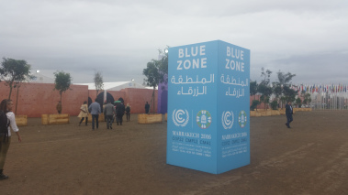

DAY THREE: QUALITY GLOBAL FOREST SURVEYS USING SATELLITES AND TRUMP TRUMP TRUMP
  - November 9, 2016
By Charlotte Ross-Harris
The development of more comprehensive satellite imagery is making forest management and assessment much easier and more detailed. Throughout the many workshops I attend or accidentally stumble upon, I have seen many different applications of the technology. The extremely high level resolution images being produced now are the first to provide conclusive imagery of scarce woodlands or drylands. A potential carbon sink that has been previously ignored or left out of many assessments. The ability to undertake a quality global forest survey using satellite imagery not only saves us a lot of time, it is leading us towards a transparent world of forestry. Additionally, there seems to be a big push towards open and free data sharing. This access to global tree cover distribution is hugely valuable to monitor land restoration and makes countries accountable for the promises they make. In terms of carbon, they can map biomass change through time and calculate carbon uptake and emissions. Whilst deforestation (and the associated carbon emissions) is relatively easy to see, this development is making forest degradation more easily identified, which is essential information to obtain. Having this science based evidence is crucial in steering policy direction. This is especially relevant for indigenous communities whose contribution to the health and conservation of forests is largely ignored. In Brazil this mapping shows clearly how protected indigenous lands are associated with healthier forests. With a new study producing annual reports on the carbon storage change throughout the Brazilian Amazon, the indigenous peoples are able to advocate for their territorial rights and conservation of their forests. This conclusive scientific data cannot be ignored by policy makers and will make monitoring of programs such as REDD+ simple and transparent.
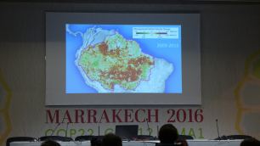
Trump Trump Trump
It has been hard to ignore United States politics today and stay focused on climate change, as one disgruntled American advised me to do on the bus this morning. The youth of SustainUS and other concerned COP attendees gathered with signs and banners to protest Trump’s election. SustainUS made a commitment to stand by the most climate affected countries and promise to stage a mass civil disobedience over the next 4 years to keep fossil fuels in the ground. A powerful moment indeed.
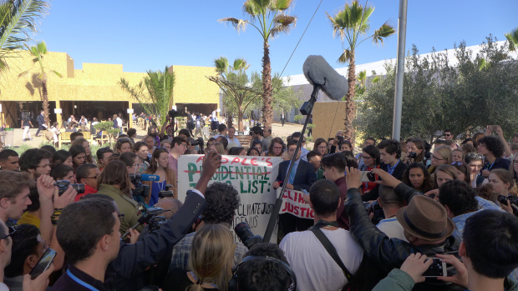

PROMOTING SOCIAL FORESTRY IN INDONESIA
  - November 9, 2016
By Vicky Tremblay
Good evening!
Today, I went to a presentation on the social aspect of forestry in Indonesia. This pavilon is very warmhearted, just like the people who run it. Indonesia is a transcontinental country located mainly in Southeast Asia. There is about 17 508 islands and it is the largest archipelago in the world with an estimated population of 250 million people, it is the fourth most populous country in the world. So you can guess that climate change is a big deal for them since they are very vulnerable to rising of water. However, today the topic was forestry from a social perspective, as well as their application in programe REDD +. I also assisted to a presentation of the indiginous Indonisan people who have a very interisting point of view on forest management. In fact, the forest under their responsibility are well preserved. When there is illegal harvesting, they usually find the responsibles and bring them to trial or otherwise, they curse them. They have beliefs in the trees and the forest and transmit very old proverb through generations to preserve nature. For example: It is the forest that causes the rain to be used to grow rice, corn and a source of water. I was inspired by their will and their passion for forest and I hope I interested you enough to learn more about it. Bye!
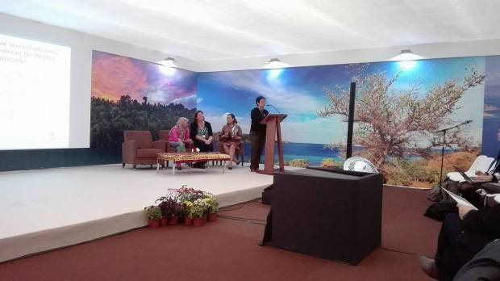

DAY FOUR: YOUTH AND FUTURE GENERATIONS IN CLIMATE
  - November 10, 2016
By Charlotte Ross-Harris
Currently 50% of the global population is comprised of youth. Yet there are very few opportunities for young members of society to impact on decision making. As one young speaker pointed out today – they are in there next door right now talking about us, without us. We are the generation of climate change. We take the Sustainable Development Goals outlined in the Paris Agreement forward and are responsible to amend the state of our climate. We cannot face the upcoming generation with regret for our actions, we must pass on a legacy. And ensure the realization of this agenda. The impassioned and deeply inspiring speeches made by young and old today all sang the same message: we must ensure the youth are involved in the decision making process. The negotiations must include all involved demographics and despite being young and relatively inexperienced, the youth are qualified to make decisions – it is about the capacity of the person, not their age.
The youth of this world are the engines of social change, and I heard from some really powerful young people today who are taking responsibility into their own hands. For example, a young girl from Mauritius saw the gaps in education amongst her peers and gathered help to begin informing them of who the UNFCCC is, what happens at COP and why the Paris Agreement is so promising. She is trying to make the Paris Agreement “cool” amongst her peers, and why should it not be? Another young man from China has organized to bring 20 young Chinese delegates ranging from 14-30 years old to COP this year, a feat that requires a full year of fund raising and spreads so much awareness.
There are many good examples of youth groups working from the bottom up to spread awareness and increase the knowledge amongst groups. The youth here are energized and ambitious. And it is no wonder why – not only do we inherit the problem, we inherit the solutions too.
Some advice I noted down throughout the day: Make noise. Do not be assured with promises. Demand results.

GROUNDED SOIL
  - November 16, 2016
Degraded Soil Management as Part of Mitigation Action
By Branindityo Nugroho
This session took place in the Italy Pavilion and it discussed our current and future challenges with extreme weather and the relation to forced displacement. Here is a brief overview of the situation and why we are not particularly ready to overcome this problem.
Poverty –> Illegal economy –> Corruption –> Fanaticism and Terrorism –> Overexploitation –> Migration
…and it causes an even worse feedback loop:
Environmental Stress –> Social Cohesion Collapse and Conflict –> Loss of Mitigation and Adaptation Capability –> Even more Environmental Stress
Add to this climate change and the additional fragility of soil and soil degradation and picture the tragedy we had to defuse. Environmental modifications cause the contraction, loss or displacement of ecosystem services such as:
- Productivity, and also purification
- Bio-sanitary
- Local climate regulation services
- Empowerment and cultural identity services
Cultural Identity Services encompasses the concept that humans have adapted to the circumstances they’re born in – their immediate environment. So when there is any significant difference in that landscape, which exceeds the human ability to overcome, then the only option left is to move to another place. Upon a move to a new location, it is quite likely that humans will spark new changes and alterations in this new environment. At the end of the day it is a simultaneous, multiplied effect on the whole globe.
And since all of us struggling to keep this planet below that 2 degrees that we agreed, then all of us should be on board, including helping fragile areas and those who live in them.
The cost of recovering one acre of degraded land are various, ranging from 80 USD in semi-degraded fertile area to 22 000 USD for complex coastal biomes.
In most tropic countries where the degradation insecurity nexus is emerging, the cost is around 200 USD. With this approximate number, the recovery of each acre turns into a well-measured-effective-carbon-action.
The recovery of lands -especially if they are given to trained small scale family farmers- lead to:
- Create effective carbon absorption mechanism
- Enables local mitigation
- Defends hydrologic system
- Protect biodiversity
- Restore productivity
- An agricultural surplus that enables manufacturing activities
- Local family and gender empowerment
- A stronger civil cohesion and lessened migratory impulse
- Lifestyles and dignity dimensions that illegitimate fanatics
- Valorize traditional know how, modernize it, strengthen local identity
So it is important to keep ourselves grounded in managing the land and soil. Moreover it’s a limited core resource for every single living organism in this planet. Be grounded!

FUTURE VISIONS
  - November 15, 2016
By Maximillion Schubert
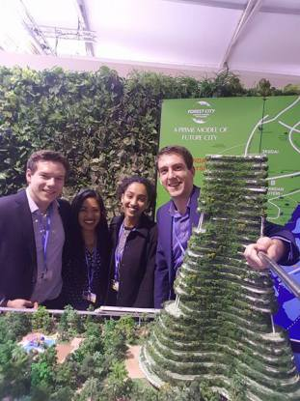
Today was our first day at COP22 in Marrakech. After a short orientation phase we dove right into our first session. Luckily today was “education day” so we could gain a lot of knowledge relevant to IFSA’s vision.
Hearing all of the different aspects of environmental protection and restoration you come to think about what more we could do than simply restoring what has been destroyed.
Hereby we came across a very interesting concept from a Malaysian Company which currently builds so called “forest cities”. They first took four small sandbanks close to their shore to begin extending and reclaiming them. Then they constructed buildings which perfectly fit in the landscape. While doing so, they transplanted all of the trees to a special wetland area, which is used for filtering water and providing a silt-curtain in the ocean to collect waste from the construction. The new buildings all function in an environmentally friendly way, such as by collecting rain water and housing solar panels. Furthermore, they have rooftop gardens and the frontage of the buildings are covered in green plants.
Now they want to enhance this concept by building a more level system, which has a bottom level parking space, a second level highway under the ground and a street level city. It is so interesting, and yet so crazy – in a good way of course! Their aim is to achieve a green, environmentally friendly city, without any cars.
But as Mr Yu Runze pointed out, ”It’s not about how things work now but about how you want to have things working in the future.”
Hopping from session to session there was not much time for food. While some of us just grabbed some sandwiches on the street, others took the time exploring both the green and blue zones in greater depth – all the while consuming free sweet goods which magically appeared after each session.
We spent the rest of the day examining every countries stands and looking for interesting sessions to take part in. Overwhelmed by the beauty of really amazing water features and 3d-projections, we stumbled across a huge digital world model at the USA office where you could let different scenarios of climate change run. This shows you, awfully directly, what is going to happen if we don’t address climate change.
Tired from a long and exciting first day we left when the sun had already set and enjoyed the super moon from the bus on our way back to Medina.

